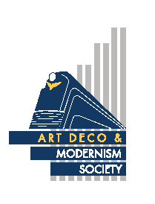
Melbourne Modernism Walk

Postwar Melbourne embraced new styles of architecture and saw the introduction of the latest designs, building techniques and materials. This walk will cover a range of Modernist buildings, including office blocks (commercial and government), banks, cinemas, car parks and hotels. The 1956 Olympic Games started an exciting era for Melbourne which carried on through the 1970s. Please join us for the first Modernist Walking tour conducted by ADMSA.

Date: | Sunday, 5th February 2017
Start Time | 9:45 am for a 10 o’clock start
Start Point: | Orica House, Cnr Albert St and Nicholson St, East Melbourne
Cost: | $30 (includes walk booklet)

- - - - - - - - - - - - - - - - - - - - - - - - - - - - - - - - - - - - - - - - - - - - - - - - - - - - -

B O O K I N G F O R M
No of persons: [Cost: $30 per person]
Name(s):________________________________________________________________________________
_______________________________________________________________________________________
Tel. contact: Email: _________________________________________________
Payment can be made by:
Direct Debit - Westpac BSB: 033-048 Account: 851024 (please notify us by email at robynsaalfield@ihug.com.au)
Cheque or money order payable to Art Deco & Modernism Society of Australia Inc.
Credit card
Visa MasterCard Expiry date: _____/______
Card number:
Cardholder’s name: _______________________________________________________________________
Amount: $____________ Signature: _______________________________________________________
Forward booking form to: Art Deco & Modernism Society of Australia Inc., PO BOX 17, CAMBERWELL, VIC 3124. All bookings to be received no later than Thursday, 2nd February 2017.
Art Deco & Modernism Society of Australia Inc. is an Incorporated Association pursuant to the Associations Incorporation Act 1981 (Vic). www.artdeco.org.au

