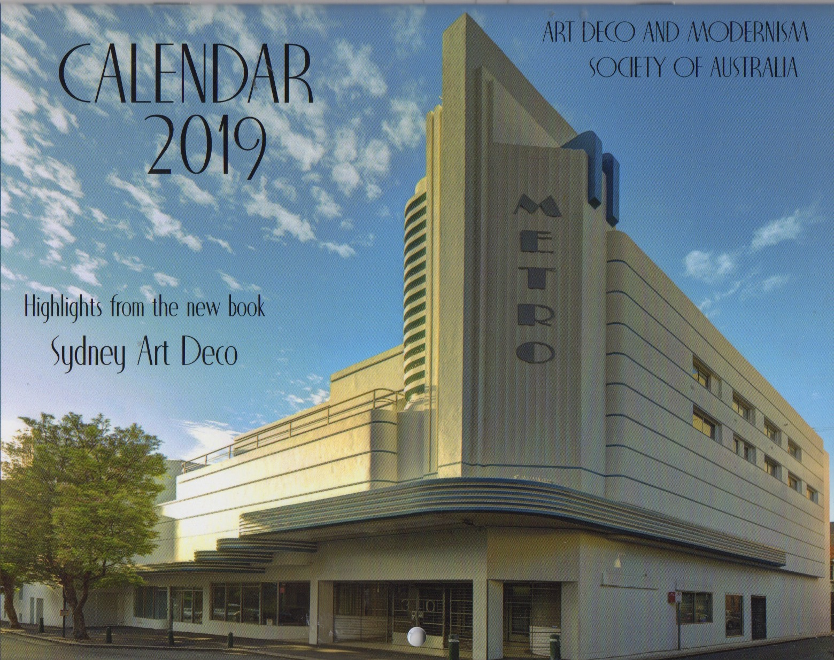

Calendar 2016

ART DECO AND MODERNISM SOCIETY OF AUSTRALIA

CALENDAR 2019

Yes, I would like to order the AD&MSA calendar for 2019. Cost $25 (includes postage and handling) or $20 if picked up. Overseas price on application to robynsaalfield@ihug.com.au

Name: …………………………………………………………………………………………………………………....

Address: ………………………………………………….………………………………………………………………

………………………………………….. Postcode ………..….

Number of calendars required: ________ Total amount: $_________

Payment Methods

* Direct Debit - Westpac BSB: 033-048 Account: 851024 (please notify us by email at robynsaalfield@ihug.com.au)
* Cheque payable to: Art Deco & Modernism Society of Australia
* Credit Card:  VISA  MasterCard

__ __ __ __ __ __ __ __ __ __ __ __ __ __ __ __

Expiry Date: ___/___ Name on Card: ­­­­­­­­­­­­­­­­­­­­____________________________________________

[www.artdeco.org.au](http://www.artdeco.org.au)

Mail order form and payment to:

Art Deco & Modernism Society of Australia

PO Box 17

Camberwell

Victoria 3124

Cost: $20 (pickup)

$25 (including postage & handling)

*Overseas orders price on application