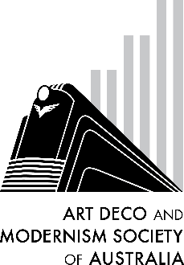Buenos Aires World Congress

OLA! Please join us for a presentation on the World Congress on Art

Deco, held in November in Buenos Aires and Plata del Mar (Argentina)

and Montevideo (Uruguay).

Share our memories as some of the attendees recount tales of the

vibrant architecture, culture, and fashion found in these exciting locations.

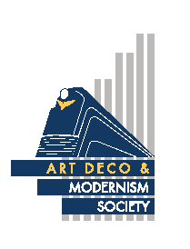

|  |  |  |  |
| --- | --- | --- | --- |
| Date: | **Thursday, 28th November 2019** |  |  |
| Starting Time: | 7:30pm for an 8 o’clock start |  |  |
| Venue: | Racecourse Hotel, cnr Dandenong Rd and Waverley Rd, East Malvern |  |  |
| Cost: | $20 members, $25 non-members (light refreshments included) |  |  |

✂

- - - - - - - - - - - - - - - - - - - - - - - - - - - - - - - - - - - - - - - - - - - - - - - - - - - - - - - - - - - - - -

B O O K I N G F O R M

**Buenos Aires World Congress**

BNo of persons: [Cost: $20 members, $ 25 non-members]

Name(s):_______________________________________________________________________

______________________________________________________________________________

Tel. contact: ______________ Email: ______________________________________________

Payment can be made by:

□ Direct Debit - Westpac BSB: 033-048 Account: 851024 (please notify us by email at robynsaalfield@ihug.com.au)

□ Cheque or money order payable to Art Deco & Modernism Society of Australia Inc.

□ Credit card

□ Visa □ MasterCard Expiry date: _____/______

Card number: □□□□ □□□□ □□□□ □□□□

Cardholder’s name: _____________________________________________________________________________

Amount: $_________ Signature: ___________________________________________________

Forward booking form to: Art Deco & Modernism Society of Australia Inc., PO BOX 17, CAMBERWELL, VIC 3124.

All bookings to be received **no later than** Tuesday, 26th November 2019.

Art Deco & Modernism Society Inc. is an Incorporated Association pursuant to the Associations Incorporation Act 1981 (Vic).

[www.artdeco.org.au](http://www.artdeco.org.au)