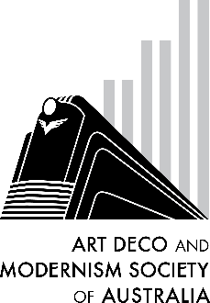 Clarice Cliff

Guest speaker, **Vaughan Macefield**, will be sharing his keen interest in the work of **Clarice Cliff,** one of the most recognized designers of ceramics during the interwar years. Inspired by her visit to the *Exposition des Arts Decoratif*s *et Industriels* and important designers like Robert and Sonia Delaunay, Cliff created her own designs featuring bold colours, fantastic geometric patterns and shapes for which she became famous. Her work was instantly popular and has continued to be so with collectors around the world.

Vaughan will explore Cliff’s work, influences and legacy in his excellent presentation. Join us for this interesting and fun evening as we return to the Racecourse Hotel for our first in-person event for 2022.

***B O O K I N G F O R M***

DATE: Thursday, 31st March 2022

TIME: 7:45pm for an 8 o’clock start

VENUE: Racecourse Hotel, cnr Dandenong Rd and Waverley Rd, Malvern East

COST: $20 members, $25 non-members (includes tea, coffee & snacks)

No of persons: [Cost: $20 per person] ________________________________

Name(s):_________________________________________________________________________

________________________________________________________________________________

Tel. contact: ______________ Email: __________________________________________________

Payment can be made by:

□ Direct Debit - Westpac BSB: 033-048 Account: 851024 (please notify us by email at robynsaalfield@ihug.com.au)

□ Cheque or money order payable to Art Deco and Modernism Society of Australia Inc.

□ Credit card

□ Visa □ MasterCard Expiry date: ______/______

Card number: □□□□ □□□□ □□□□ □□□□

Cardholder’s name: ________________________________________________________________

Amount: $____________ Signature: _________________________________________________

Forward booking form to: Art Deco and Modernism Society of Australia Inc., PO BOX 17, CAMBERWELL, VIC 3124. All bookings to be received **no later than** Tuesday, 29th March 2022.

Art Deco and Modernism Society of Australia Inc. is an Incorporated Association pursuant to the Associations Incorporation Act 1981 (Vic).

[www.artdeco.org.au](http://www.artdeco.org.au)