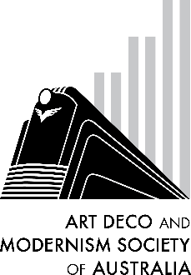
Beaumaris Modern

Our guest speaker is Fiona Austin, President of Beaumaris Modern. When Fiona, a long-time resident of Beaumaris, saw those buildings she admired were being demolished, she, along with a group of concerned residents, started this community group. Fiona will be sharing her love of this area, its location to the bay, the modernist architecture and its natural landscape.

Following her presentation on Beaumaris Modern, Fiona will talk about her ongoing interest in her Tasmanian family links to Holyman Airways – (which became Australian National Airways - ANA) and the family company ‘Modern Art Furniture’ which designed the furniture and interiors for passenger terminals around Australia.

B O O K I N G F O R M

DATE: Thursday, 26th May 2022
TIME: 7:45pm for an 8 o’clock start
VENUE: Racecourse Hotel, cnr Dandenong Rd and Waverley Rd, Malvern East
COST: $20 members, $25 non-members (includes tea, coffee & snacks)

No of persons: [Cost: $20/$25 per person] _________________________
Name(s):_________________________________________________________________________
________________________________________________________________________________
Tel. contact: ______________ Email: __________________________________________________
Payment can be made by:
Direct Debit - Westpac BSB: 033-048 Account: 851024 (please notify us by email at robynsaalfield@ihug.com.au)
Cheque or money order payable to Art Deco and Modernism Society of Australia Inc.
Credit card
Visa MasterCard Expiry date: ______/______
Card number:

Cardholder’s name: ________________________________________________________________
Amount: $____________ Signature: _________________________________________________
Forward booking form to: Art Deco and Modernism Society of Australia Inc., PO BOX 17, CAMBERWELL, VIC 3124. All bookings to be received no later than Tuesday, 24th May 2022.

Art Deco and Modernism Society of Australia Inc. is an Incorporated Association pursuant to the Associations Incorporation Act 1981 (Vic).
www.artdeco.org.au

