Elwood Walk

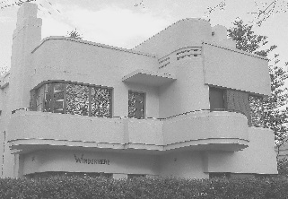
The area of Elwood contains some fine examples of interwar architecture. Our walk includes some outstanding apartment blocks, from Streamline to Mediterranean. The work of a number of prominent architects will also be featured.

Date: | Sunday, 23rd October, 2022.
Starting Time: | 9:45 for a 10:00am start
Venue: | Starting point: outside the Burnett Gray Infant Welfare centre, 51 Broadway
Cost: | $30 members; $35 non-members (booklet supplied)

- - - - - - - - - - - - - - - - - - - - - - - - - - - - - - - - - - - - - - - - - - - - - - - - - - - -

B O O K I N G F O R M

Yes, I wish to attend the Elwood Walk on Sunday, 23rd October 2022.

No of persons: [Cost: $30 per person]
Name(s): _______________________________________________________________________________

Tel. contact: Email: _________________________________________________

Payment can be made by:
Direct Debit - Westpac BSB: 033-048 Account: 851024 (please notify us by email at robynsaalfield@ihug.com.au)
Cheque or money order payable to Art Deco & Modernism Society of Australia Inc.
Credit card
Visa MasterCard Expiry date: _____/______
Card number:
Cardholder’s name: _______________________________________________________________
Amount: $_______ Signature: _______________________________________________________

Forward booking form to: Art Deco & Modernism Society of Australia Inc., PO BOX 17, CAMBERWELL, VIC 3124. All bookings to be received no later than Thursday, 21th October 2022.

www.artdeco.org.au

