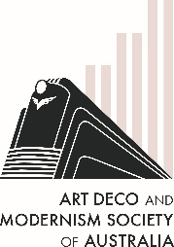
The Art Deco & Modernism Society of Australia
presents
Deco Divas – Silent movie stars
who inspired Art Deco artists
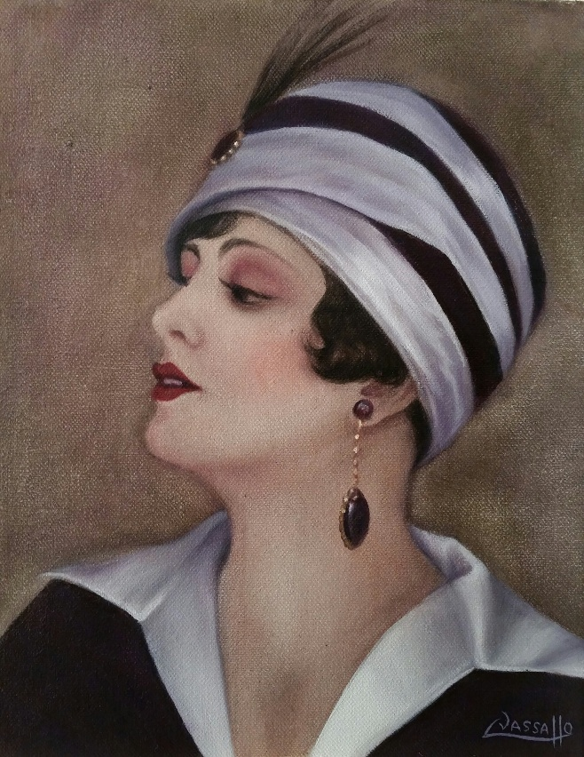 | Leanne Vassallo’s Deco Divas focuses upon the many silent movie stars that inspired artists during the Art Deco era. From Erte, who created daring beaded fashions including the costume for Mata Hari, to portraits of Pola Negri and Greta Garbo.  Leanne’s presentation shines a spotlight on the Australian actresses and artists who found fame in Hollywood. This includes Henry Clive, a Melbourne born magician, artist and illustrator, who created portraits in pastel of stars including Joan Crawford and Clara Bow for movie posters and magazines. Leanne will share the inspiration behind her ‘Deco Diva’ portrait series of her favourite muse, Miss Phryne Fisher, made famous in the Miss Fisher’s Murder Mysteries TV series, based on the novels by the recently departed Kerry Greenwood.  Leanne will show many items of interest from her collection and her Deco Diva paintings and prints that Art Deco lovers are sure to admire and enjoy.
Date: Thursday 19 June 2025
Time: 7:45 pm for 8:00 pm
Venue: The Glasshouse Caulfield (in Caulfield Racecourse)
31 Station Street Caulfield East 3145
———————————————————————————————————
Book by Monday 16 June 2025 at TryBooking https://www.trybooking.com/DBZMS (+ $0.50 booking fee) or complete this form to pay by card, cheque or EFT
Number of members at $30: _____________ Number of non-members at $35 ______________
Name(s): _________________________________________________________________________________
_________________________________________________________________________________________
Tel: ______________ Email: _______________________________________________________
⬜ EFT: Westpac BSB: 033-048 Account: 851024 and email transaction to the Secretary robynsaalfield@ihug.com.au
⬜ Cheque or money order payable to Art Deco & Modernism Society of Australia Inc.
Credit card ⬜ Visa ⬜ MasterCard
Card number: ⬜⬜⬜⬜ ⬜⬜⬜⬜ ⬜⬜⬜⬜ ⬜⬜⬜⬜ Expiry date: ______/______
Cardholder’s name: ______________________________________________________________
Amount: $ ____________ Signature: ________________________________________________
- email: robynsaalfield@ihug.com.au
- mail: to Art Deco & Modernism Society of Australia Inc PO Box 17 CAMBERWELL VIC 3124

Art Deco & Modernism Society of Australia Inc is an Incorporated Association pursuant to the Associations Incorporation Act 1981 (Vic)
www.artdeco.org.au

