
The Art Deco & Modernism Society of Australia
Presents a walking tour of
Spanish Mission and Mediterranean Melbourne
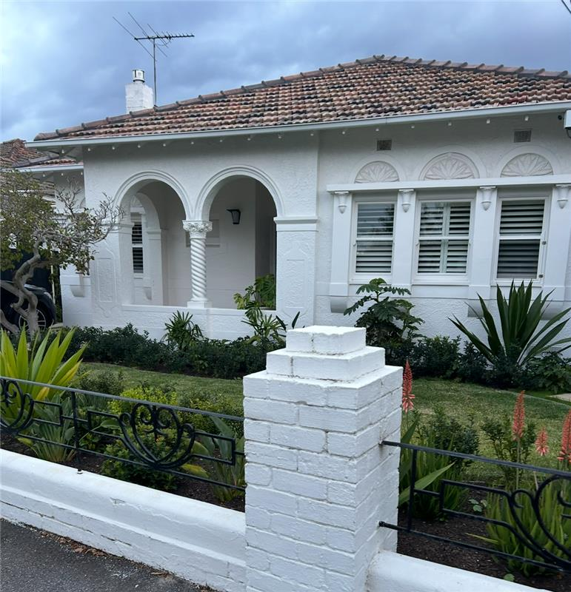 | Both Spanish Mission and Mediterranean styles share a flair for evoking sunnier climes and seaside charm against Melbourne’s grey skies.  This walk features notable and diverse examples of these styles across Ripponlea, St Kilda and Elwood, the three suburbs which are home to the highest concentrations of Spanish Mission and Mediterranean buildings in Melbourne.  Join ADMSA committee member Sam Taylor on a walking tour to discover these delights.  Bring your water bottle and dress for the weather.

Date: Sunday 20 July 2025
Time: 10:30 am to 12:30 pm
Meet at 10:20 am Ripponlea Railway Station
(in the park on the ‘towards city’ side)
———————————————————————————————————
Book by Monday 16 July 2025 at TryBooking https://www.trybooking.com/DCZOA
(+ $0.50 booking fee) or complete this form to pay by card, cheque or EFT
Number of members at $45: _____________ Number of non-members at $50 ______________
Name(s): _________________________________________________________________________________
_________________________________________________________________________________________
Tel: ______________ Email: _______________________________________________________
⬜ EFT: Westpac BSB: 033-048 Account: 851024 and email transaction to the Secretary robynsaalfield@ihug.com.au
⬜ Cheque or money order payable to Art Deco & Modernism Society of Australia Inc.
Credit card ⬜ Visa ⬜ MasterCard
Card number: ⬜⬜⬜⬜ ⬜⬜⬜⬜ ⬜⬜⬜⬜ ⬜⬜⬜⬜ Expiry date: ______/______
Cardholder’s name: ______________________________________________________________
Amount: $ ____________ Signature: ________________________________________________
- email: robynsaalfield@ihug.com.au
- mail: to Art Deco & Modernism Society of Australia Inc PO Box 17 CAMBERWELL VIC 3124

Art Deco & Modernism Society of Australia Inc is an Incorporated Association pursuant to the Associations Incorporation Act 1981 (Vic) https://www.trybooking.com/DCZOA
www.artdeco.org.au

