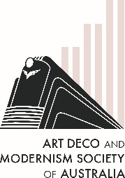
The Art Deco & Modernism Society of Australia
presents
Michael Rigg: An Architectural tour
of the Castlemaine Art Museum
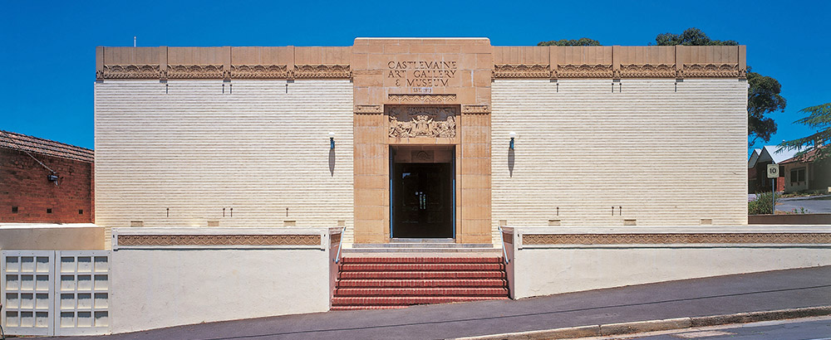

Join us to hear Michael Rigg present insights into the purpose-built Art Deco Castlemaine Art Museum completed in 1931. The National Trust heritage-listed building was designed by architect Percy Meldrum.
Retired architect and past president of the Master Builders’ Association, Michael will highlight the architectural gems and fabric of the Museum as well as its architect.
Architect Percy Meldrum was influenced by Frank Lloyd Wright and designed aircraft hangars for the English War Office before settling back in Melbourne. He was a fine water colourist and collaborated with Napier Waller, whose mosaic features on the façade of Newspaper House in Melbourne (1933).
Date: Thursday 14 August 2025
Time: 7:45 pm for 8:00 pm
Venue: The Glasshouse Caulfield (in Caulfield Racecourse)
31 Station Street Caulfield East 3145
———————————————————————————————————
Book by Monday 11 August 2025 at https://www.trybooking.com/DDXLB or complete this form to pay by card, cheque or EFT
Number of members at $30: _____________ Number of non-members at $35 ______________
Name(s): _________________________________________________________________________________
_________________________________________________________________________________________
Tel: ______________ Email: _______________________________________________________
⬜ EFT: Westpac BSB: 033-048 Account: 851024 and email transaction to the Secretary robynsaalfield@ihug.com.au
⬜ Cheque or money order payable to Art Deco & Modernism Society of Australia Inc.
Credit card ⬜ Visa ⬜ MasterCard
Card number: ⬜⬜⬜⬜ ⬜⬜⬜⬜ ⬜⬜⬜⬜ ⬜⬜⬜⬜ Expiry date: ______/______
Cardholder’s name: ______________________________________________________________
Amount: $ ____________ Signature: ________________________________________________
- email: robynsaalfield@ihug.com.au
- mail: to Art Deco & Modernism Society of Australia Inc PO Box 17 CAMBERWELL VIC 3124

Art Deco & Modernism Society of Australia Inc is an Incorporated Association pursuant to the Associations Incorporation Act 1981 (Vic)
www.artdeco.org.au

