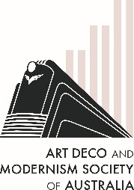
The Art Deco & Modernism Society of Australia
Presents a walking tour of
Walking tour of Modernist Melbourne – City East
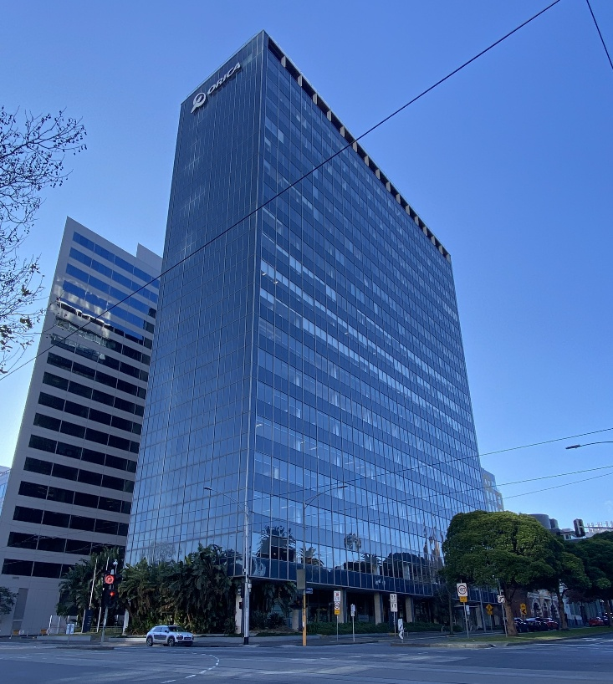 | Join us for a captivating exploration of Modernist Melbourne in the east of the CBD, where we’ll uncover architectural treasures that illustrate the transformation of Melbourne’s built environment in the post-WWII period.  Our tour begins with the iconic 1958 ICI building on Nicholson Street, a striking example of International Style architecture featuring clean lines, curtain walls of glass, and an innovative use of reinforced concrete.  From there, you’ll marvel at a range of Brutalist buildings including a fire station, with its raw concrete facades and imposing geometric form, discover cinemas that embraced modernist aesthetics in their streamlined designs, and car parks with sculptural ramps that are as much art as utility.  We’ll also explore brick apartment towers, built between the 1950s and 1980s when the first wave of City Living was all the rage and so much more.  Bring your water bottle and dress for the weather.
Date: Sunday 21 September 2025, 10:30 am to 12:00 pm
Meet at 10:15 am Parliament Gardens: Corner Albert and Nicholson Streets East Melbourne
———————————————————————————————————
Tickets capped at 20. Book early to avoid disappointment at https//www.trybooking.com/DDXLG or complete this form to pay by card, cheque or EFT
Number of members at $45: _____________ Number of non-members at $50 ______________
Name(s): _________________________________________________________________________________
_________________________________________________________________________________________
Tel: ______________ Email: _______________________________________________________
⬜ EFT: Westpac BSB: 033-048 Account: 851024 and email transaction to the Secretary robynsaalfield@ihug.com.au
⬜ Cheque or money order payable to Art Deco & Modernism Society of Australia Inc.
Credit card ⬜ Visa ⬜ MasterCard
Card number: ⬜⬜⬜⬜ ⬜⬜⬜⬜ ⬜⬜⬜⬜ ⬜⬜⬜⬜ Expiry date: ______/______
Cardholder’s name: ______________________________________________________________
Amount: $ ____________ Signature: ________________________________________________
- email: robynsaalfield@ihug.com.au
- mail: to Art Deco & Modernism Society of Australia Inc PO Box 17 CAMBERWELL VIC 3124

Art Deco & Modernism Society of Australia Inc is an Incorporated Association pursuant to the Associations Incorporation Act 1981 (Vic) https://www.trybooking.com/DCZOA
www.artdeco.org.au

