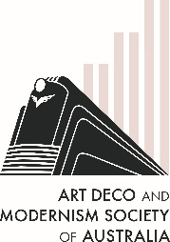
The Art Deco & Modernism Society of Australia
Presents
From Modernism to Postmodernism: Art Deco revival and the evolution of architectural style
Join RMIT Architectural Historian Conrad Hayman as he explores the many reinventions of 20th century styles spanning neo-futurism, metabolism, modernism and the emergence of postmodernism in the late 1970s.  Postmodernism is a vibrant, eclectic style that reacted against the austerity and uniformity of mid-century architecture. It embraced complexity, historical references, ornamentation, asymmetry, bright colors, and playful contradictions to create buildings that engage with their cultural and contextual surroundings.  Conrad explores how Art Deco and Modernism were expressed and reinterpreted through the evolution of styles. | 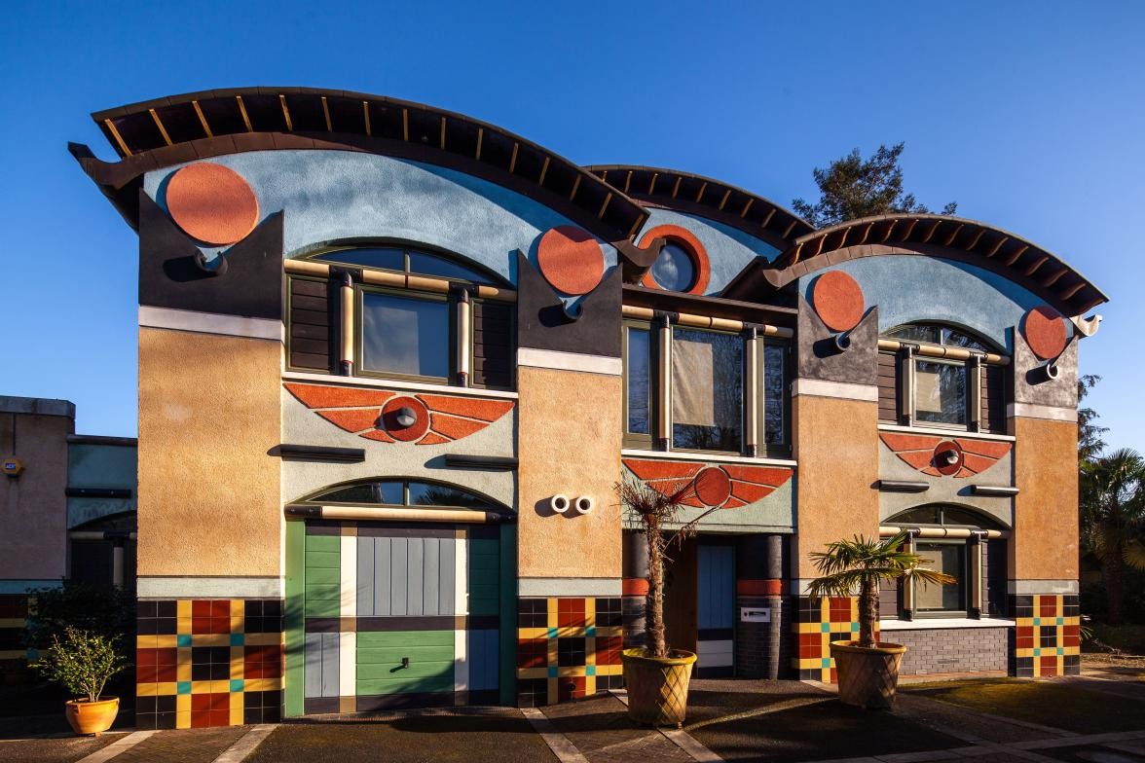  Photo credit: Phil Sayer, C20 Society
Date: Thursday 18 September 2025
Time: 7:45 pm for 8:00 pm
Venue: The Glasshouse Caulfield (in Caulfield Racecourse)
31 Station Street Caulfield East 3145

———————————————————————————————————
Book by Monday 15 September 2025 at https://www.trybooking.com/DDXLL
or complete this form to pay by card, cheque or EFT
Number of members at $45: _____________ Number of non-members at $50 ______________
Name(s): _________________________________________________________________________________
_________________________________________________________________________________________
Tel: ______________ Email: _______________________________________________________
⬜ EFT: Westpac BSB: 033-048 Account: 851024 and email transaction to the Secretary robynsaalfield@ihug.com.au
⬜ Cheque or money order payable to Art Deco & Modernism Society of Australia Inc.
Credit card ⬜ Visa ⬜ MasterCard
Card number: ⬜⬜⬜⬜ ⬜⬜⬜⬜ ⬜⬜⬜⬜ ⬜⬜⬜⬜ Expiry date: ______/______
Cardholder’s name: ______________________________________________________________
Amount: $ ____________ Signature: ________________________________________________
- email: robynsaalfield@ihug.com.au
- mail: to Art Deco & Modernism Society of Australia Inc PO Box 17 CAMBERWELL VIC 3124

Art Deco & Modernism Society of Australia Inc is an Incorporated Association pursuant to the Associations Incorporation Act 1981 (Vic) https://www.trybooking.com/DCZOA
www.artdeco.org.au

