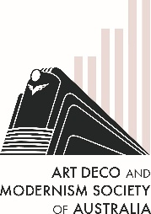
The Art Deco & Modernism Society of Australia
presents
Highlights of the 2025 Art Deco Congress tours of Reims, St Quentin and Brussels
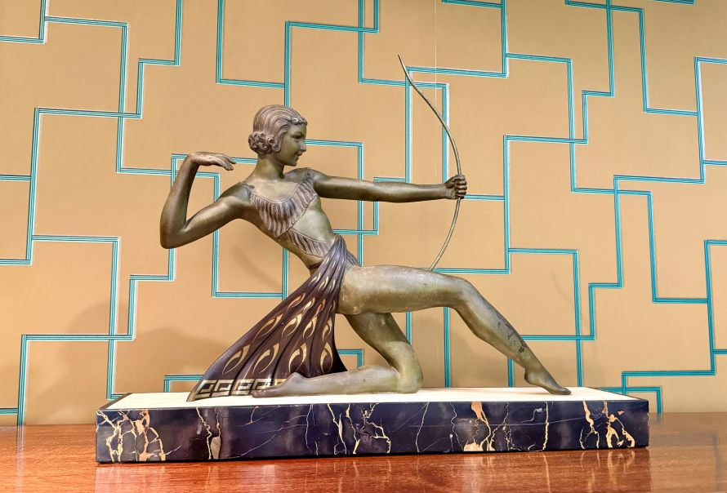 | Following our December presentation of highlights of the Paris Congress, join us for highlights of the Pre-Congress tour of Reims and St Quentin and the Post-Congress tour of Brussels.  Hear from our members about Reims, 'The martyred city' of WWI, that was rebuilt in the modern style that became known as Art Deco, and St Quentin’s Art Deco delights.  Then we'll visit Brussels, to learn how it threw off its Art Nouveau heritage and embraced the modern Deco style.
Date: Thursday 15 January 2026
Time: 7:45 pm for 8:00 pm
Venue: Caulfield RSL, 4 St Georges Road Elsternwick 3185
———————————————————————————————————
Book at by Monday 12 January at TryBooking https://www.trybooking.com/DHOHJ or complete this form to pay by card, cheque or EFT
Number of members at $30: _____________ Number of non-members at $35 ______________
Name(s): _________________________________________________________________________________
_________________________________________________________________________________________
Tel: ______________ Email: _______________________________________________________
⬜ EFT: Westpac BSB: 033-048 Account: 851024 and email transaction to Robyn Saalfield, robynsaalfield@ihug.com.au
⬜ Cheque or money order payable to Art Deco & Modernism Society of Australia Inc.
Credit card ⬜ Visa ⬜ MasterCard
Card number: ⬜⬜⬜⬜ ⬜⬜⬜⬜ ⬜⬜⬜⬜ ⬜⬜⬜⬜ Expiry date: ______/______
Cardholder’s name: ______________________________________________________________
Amount: $ ____________ Signature: ________________________________________________
- email: robynsaalfield@ihug.com.au
- mail: to Art Deco & Modernism Society of Australia Inc PO Box 17 CAMBERWELL VIC 3124

Art Deco & Modernism Society of Australia Inc is an Incorporated Association pursuant to the Associations Incorporation Act 1981 (Vic)
www.artdeco.org.au

