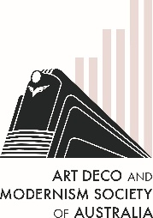
The Art Deco & Modernism Society of Australia
presents
Highlights of the Paris 2025 Art Deco Congress
Join us for an Art Deco immersion of the beginnings of Art Deco in 1925 and its spread across Paris and the world.  The Paris Art Deco Congress in October 2025 celebrated 100 years of all things Art Deco across 6 days. Four of our members will share their Congress highlights with you.  You’ll hear the story of the 1925 Paris International Exhibition of Modern Decorative and Industrial Arts told through the Congress lectures, see Paris’s best Deco buildings, interiors, furniture, jewelry, and clothing visited on the tours and in museums, and get a taste of glamorous cafes, restaurants, dancing and parties.  An event not to be missed – both by those who couldn't go to feel like they were there, and for those who went to reminisce.  Arrive by 7:50 pm for an 8:00 pm start. | 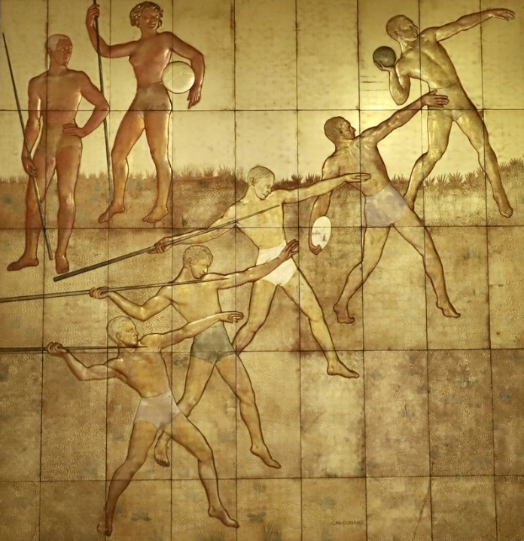  Photo credit: Barry Clare
Date: Thursday 11 December 2025, 7:45 pm for 8:00 pm
Venue: Caulfield RSL
4 St Georges Road Elsternwick 3185
———————————————————————————————————
Book by Monday 8 December 2025 at https://www.trybooking.com/DHOGS
or complete this form to pay by card, cheque or EFT
Number of members at $30 _____________ Number of non-members at $35 ______________
Name(s): _________________________________________________________________________________
_________________________________________________________________________________________
Tel: ______________ Email: _______________________________________________________
⬜ EFT: Westpac BSB: 033-048 Account: 851024 and email transaction to Robyn Saalfield, robynsaalfield@ihug.com.au
⬜ Cheque or money order payable to Art Deco & Modernism Society of Australia Inc.
Credit card ⬜ Visa ⬜ MasterCard
Card number: ⬜⬜⬜⬜ ⬜⬜⬜⬜ ⬜⬜⬜⬜ ⬜⬜⬜⬜ Expiry date: ______/______
Cardholder’s name: ______________________________________________________________
Amount: $ ____________ Signature: ________________________________________________
- email: robynsaalfield@ihug.com.au
- mail: to Art Deco & Modernism Society of Australia Inc PO Box 17 CAMBERWELL VIC 3124

Art Deco & Modernism Society of Australia Inc is an Incorporated Association pursuant to the Associations Incorporation Act 1981 (Vic) https://www.trybooking.com/DCZOA
www.artdeco.org.au

